

**COLOR KEY**

**Sand Heather**

**Cabernet Heather**

**Denim Heather**

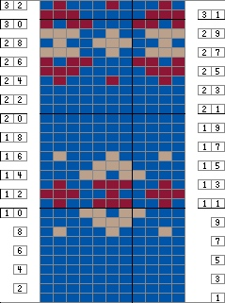

**8-st rep**

**Beg**

**End**