Ruffle Tank Schematic Measurements.
All measurements are made after blocking and before trimming.

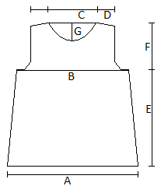

A – 19 (21.25, 23.5, 25.5, 27.75, 30, 32)”

B – 18 (20, 22.25, 24.5, 26.5, 28.75, 31)”

C – 8 (8.75, 9, 9.5, 9.75, 9.75, 10.5)”

D – 2.5 (3, 3.5, 3.75, 4, 4, 4.75)”

E – 16 (16.5, 16, 16.5, 16.5, 16.5, 16.5)”

F – 7.5 (8, 8.75, 9, 9.25, 10, 10)”

G – 3.25”

